CCR Report for February 22, 2024 CA Board Meeting

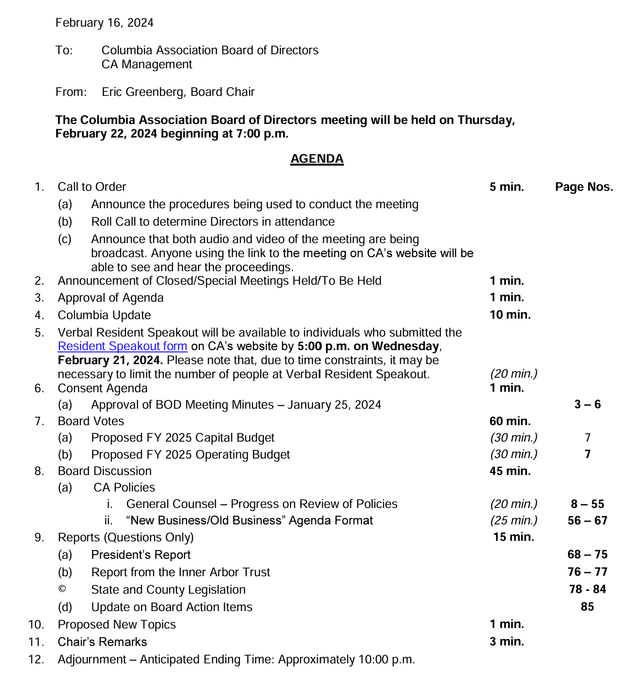

- You can view recordings of the meetings, review the agenda, and find the full packet of materials here:
    - https://columbiaassociation.org/about-us/leadership/board-of-directors/archived-meetings/

- Call to Order
- Approval of Agenda
- Columbia Update
  - Snow event preparation and management
    - Brining (prior to storm) vs. rock salt (during storm)
  - February is Heart Month
    - Cardiovascular fitness at the gyms and clubs
    - Have Automatic Defibrillators in all facilities and train employees to use them if needed
    - Free CPR classes for employees, especially lifeguards (over 500 team members certified)
  - Art
    - Young students displaying art in gallery at the Columbia Art Center
  - Pop Up Videos
    - Heart Health facts overlayed on video of people exercising at the gyms
    - Exercise on the pathways

- Resident Speakout
  - Michelle Krupka - Columbia Arts Center
    - See the updates being made at the gyms and would like to have similar updates be made to the Columbia Arts Center - specifically the maintenance for the gas kilns
    - Different finishes can be obtained with gas and electric kilns
    - After 50 years of fixes, a new gas kiln is needed to replace the old ones
    - Kilns are costly, but classes are expensive and students expect that they'd get great results provided by a gas kiln
    - 18 cu ft = $35k; only 1 gas kiln remains out of 5
    - Dennis to confirm that a new gas kiln is part of the renovation
  - Bob Dover - not present
    - Testimony sent via email
  - Joel Hurwitz
    - Policies
      - Ask questions but don't have a discussion - don't follow this
      - Policy update submitted by Karen; should amending the charters and put leases back in the charter
    - Discussion about if easements end - construction easements end
    - Policy update in packet - glad to see it
  - Amy Brooks
    - Homeowner in Oakland Mills - people have concerns
    - Seeing Board Members meeting outside of the formal Board meetings
    - Why are these meetings happening, are people aware of them, what is being discussed?
  - Sharon Boies
    - Concern over budget surplus - $5M (?); dredging, etc. - does not consider retention bonuses a good use of surplus money
    - Iron flocculate bloom in water and disturbance by stream restoration - negative effects on stream life

- Consent Agenda
    - Approval of BOD Meeting Minutes (1/25/24) - Approved by consent

- Board Votes
    - Proposed FY 2025 Capital Budget
      - Move to approve and seconded
        - Motion raised to add $200k for Inner Arbor Trust - motion failed
        - Capital budget approved
    - Proposed FY 2025 Operating Budget
      - Move to approve and seconded - motion approved

- Board Discussion
  - CA Policies
    - General Counsel - Progress on Review of Policies
      - CA General Counsel is reviewing outdated policies for management - archiving, removing, superseding, etc.
      - John continues to review and wants to create a user-friendly database
    - New Business/Old Business Agenda Format
      - Bill Santos presented his proposal to be considered

- Reports (Questions Only)
  - President's Report
  - Report for Inner Arbor Trust
  - State and County Legislation
  - Update on Board Action Items

- Proposed New Topics
  - Alan Klein - Language regarding how residents can interact with board members outside their 3-5 minutes during resident speakout
    - Several Board Members recommended removing the language entirely

- Chair's Remarks
  - Completing budget process
  - Next goal is strategic plan

- Adjournment

Sincerely,

Chris Fuchs

